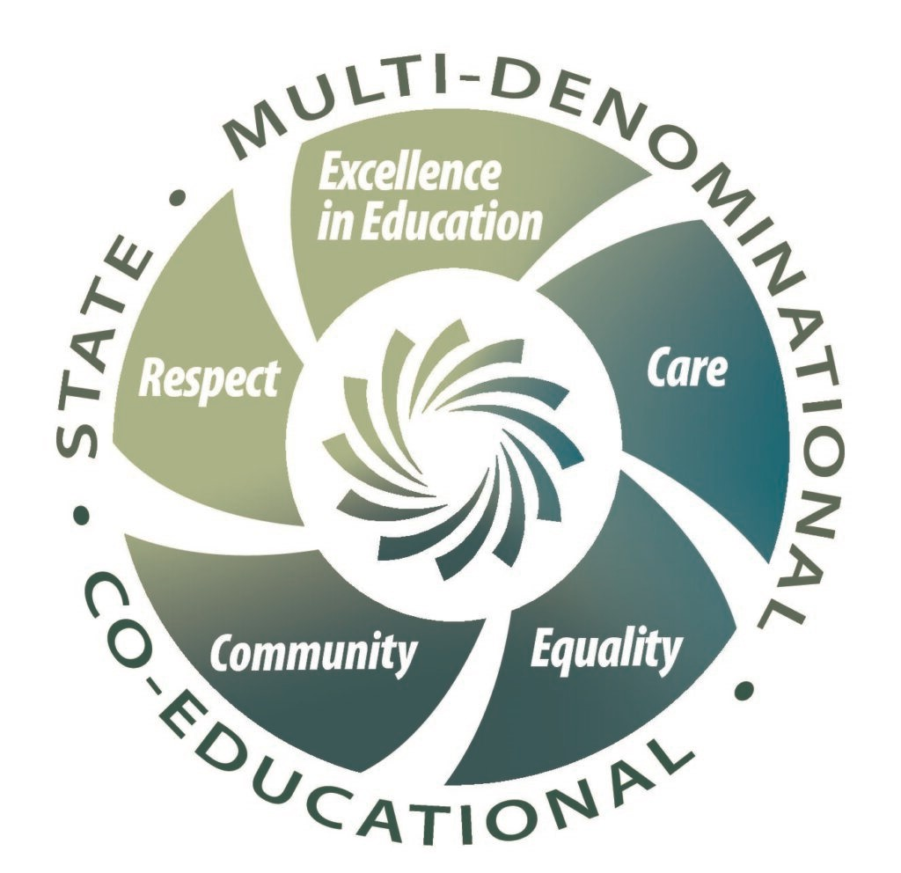
Code of Behaviour/Positive Behaviour Policy
Mission Statement
Mol an Óige Community National School is a co-educational, multi-denominational state school underpinned by the following core values:
Excellence in Education:
Education for the ‘Head, Hands and Heart’ - the Steiner pedagogical approach - is honoured through an approach that emphasises experiential, creative and active learning with a view to fostering resilience, independence and lifelong learning skills.
Care:
Mol an Óige CNS is a learning community that encourages and develops care for ourselves, care for each other and care for the environment.
Equality:
In all aspects of school life, all members of our school community are treated equitably regardless of their race, gender, religion/belief, age, family status, civil status, membership of the Traveller community, sexual orientation, ability or socio-economic status.
Community:
Mol an Óige CNS is a learning community that seeks to foster a sense of connection, community and kindness through its communal celebrations of festivals with students, staff and parents.
Respect:
Respectful attitudes towards oneself, others and the environment are nurtured and developed.
Aims of Code of Behaviour
Mol an Óige CNS aims to provide a happy, secure, friendly, learning environment, where children, parents, teachers, special needs assistants, ancillary staff, Board of Management and LCETB work in partnership. Each individual is valued, encouraged and respected for their uniqueness and facilitated to reach their full potential in a positive atmosphere.
The staff is committed to the realisation of these objectives. Our aim is to create a happy, secure environment for our pupils in which there is a sense of good order and a reasonable approach to discipline. In this way, a large group can be organised so that the school can operate smoothly for the benefit of all.
Good behaviour is based on good relations between parents/guardians, child and school. In Mol an Óige CNS, we hope to foster this ideal in co-operation with our parents/guardians. We have adopted a positive code of behaviour with emphasis on encouragement and reward so that good behaviour can prevail in our school.
The Board of Management of the school has ultimate responsibility for behaviour in the school. The LCETB must provide a safe and proper workplace for its employees. Within the school, the overall day to day responsibility for behaviour rests with the Principal. Each teacher has the responsibility for the maintenance of good behaviour and good order within his/her classroom while sharing a common responsibility for good behaviour within the school premises.
Parents/guardians can support the school by encouraging their children to understand the need for school rules, and by communicating any relevant concerns to the school.
This policy was drawn up by the Principal and In-school Management team following a process of review involving all stakeholders. Focus groups, including the Student Council, met and representatives of these groups then met for further discussion. It was then reviewed and ratified by the Board of Management. It will be reviewed each year in October. The first review will take place in October 2022.

Aims of the Code
- To create a positive learning environment that encourages and reinforces good behaviour
- To promote self-esteem and positive relationships
- To encourage consistency of response to both positive and negative behaviour
- To foster a sense of responsibility and self-discipline in pupils and to support good behaviour patterns based on consideration and respect for the rights of others
- To facilitate the education and development of every child
- To foster caring attitudes to one another and to the environment
- To enable teachers to teach without disruption
- To ensure that the school's expectations and strategies are widely known and understood through the parent’s handbook, availability of policies and an ethos of open communication
- To encourage the involvement of both home and school in the implementation of this policy

Responsibility of Adults
The adults encountered by the children at school have an important responsibility to model high standards of behaviour, both in their dealings with the children and with each other, as their example has an important influence on the children.
As adults we should aim to:
- Create a positive climate with realistic expectations.
- Promote positive behaviour, through example, honesty and courtesy.
- Provide a caring and effective learning environment.
- Encourage relationships based on kindness, respect and understanding of the needs of others.
- Ensure fair and equitable treatment for all.
- Show appreciation for the efforts and contribution of all.

School Code
- We show respect for self and others.
- We show respect for our own property and the property of others.
- We show respect for other students and their learning.
- We are kind and willing to help others.
- We follow instructions from staff immediately.
- We show courtesy and good manners.
- We try to use respectful ways of resolving difficulties and conflict.
- We ask permission to leave the classroom.
- We do our best in class.
- We take responsibility for our own work.
13. We follow our Healthy Eating Policy.
These can be summed up in the six Golden Rules:
- We listen. We don’t interrupt.
- We are gentle. We do not hurt others.
- We are honest. We tell the truth.
- We are kind and helpful. We do not hurt other’s feelings.
- We work hard. We do not waste our time or other people’s time.
- We look after property. We do not damage things.
The Golden Rules will be displayed prominently around the school.

Class Rules
At the beginning of each academic year, the class teacher will draft a list of class rules with the children, closely based on the “Golden Rules”. Class rules will be kept to a minimum and are devised with regard for the health, safety and welfare of all members of the school community. Where possible they emphasise positive behaviour (e.g. ‘Walk’ and not, ‘Don’t run’). Rules will be applied in a fair and consistent manner, with due regard to the age of the pupils and to individual difference. Where difficulties arise, parents will be contacted at an early stage.

Yard Rules

The yard rules will be displayed prominently in the yard. Any breach of yard rules will be addressed by the teacher on duty, using their professional judgement. Yard rules are reviewed annually. The 2025–2026 rules are attached.
Incentives/Reward System
Part of the vision of CNS schools is to help children achieve their personal best and thus prepare them for further education, life and work. We recognise that there are many different forms of intelligence and similarly that children use a variety of approaches to solve problems. Our reward system seeks to provide
encouragement to children of all abilities and talents. Children will be encouraged, praised and listened to by adults in the school. Praise is earned by the maintenance of good standards as well as by particularly noteworthy personal achievements. Rates of praise for behaviour should be as high as for work.
The following are some samples of how praise might be given:
A quiet word or gesture to show approval.
A comment in a pupil’s copy or homework journal.
A visit to another member of staff or to the principal for commendation.
A word of praise in front of a group or class.
Delegating some special responsibility or privilege.
A mention to parent, written or verbal communication.

School-wide Wellbeing Strategies to promote self-esteem, empathy, and resilience:
- A breathing/relaxation technique is to be implemented and used in each classroom at the discretion of the teacher. The technique chosen will be explicitly taught and embedded in the school day. An example is shown below.
- De-stress technique
- Identify stress signs (physical signs etc.)
- Tell yourself to take it easy (use class mantra, “We can do it” etc)
- Take a slow deep breath as you raise up on tiptoe, arms upraised
- Hold it for two seconds
- Slowly blow it out (count for twice as long as for the in breath while slowing bringing the arms and body back to a standing position)
- An older child may be paired up with a younger child in a junior classroom to support and mentor them as an aid to developing empathy and responsibility.
- Friends for Life programme.
- SPHE
- Regular access to the outdoors throughout the day.
If a child is not responding positively to class supports in relation to his/her behaviour, the teacher will begin the process of drawing up a behaviour improvement plan. Behaviour plans will be drawn up on a case by case basis. This plan is usually worked out with the parent/guardian so that the teacher can get a greater understanding of the rewards/sanctions that may work best for each child. If the poor behaviour continues, the teacher will meet with the child’s parents/ guardian again.
If there is no improvement following the second parent/teacher meeting and if the child is still behaving inappropriately, the parent/guardian will be called to meet with the principal and the Chairperson of the Board of Management where the situation will be discussed in detail. Guidelines will be drawn up for future behaviour in the school and playground.
Very occasionally, this may include a request from the teacher/principal that the parent/guardian of the child supervise their child in school or during a school outing.
* The school reserves the right to arrange a meeting with the parents/guardians of a child at any time, should the child’s behaviour be deemed to be unacceptable. * If a parent refuses to meet with a class teacher the matter will be referred to the principal. Any refusal to meet with the Principal and/or Chairperson will automatically be referred to the Board of Management and regarded as a serious breach of co-operation in our school behaviour policy.

Unacceptable Behaviour
Three levels of misbehaviour are recognised: minor, serious and gross. All everyday instances of a minor nature are dealt with by the class teacher, or the supervising teacher at break-times. In cases of repeated serious misbehaviour or single instances of gross misbehaviour parents will be involved at an early stage and invited to meet the teacher and/or the principal to discuss their child’s behaviour.
Examples of minor misbehaviour include: * Bringing in chewing-gum
- Not following instructions.
- Inappropriate responses to teacher correction e.g. ignoring, back answering etc.

Examples of serious misbehaviour include:
- Bringing electronic equipment or mobile-phones to school
- Using bad language
- Behaviour that is hurtful (including bullying, harassment, discrimination and victimisation)
- Behaviour that interferes with teaching and learning
- Threats or physical hurt to another person
- Damage to property
- Theft
- Bringing dangerous equipment to school
- Continued and repetitive inappropriate responses to teacher correction.
- Throwing items around the classroom in an aggressive way. * Leaving school activities without permission
Examples of gross misbehaviour include:
- Leaving school without permission
- Assault on a teacher or pupil
- Serious theft
- Serious damage to property
- Serious bullying
- Carrying drugs, alcohol, cigarettes
Bullying is repeated aggression – physical, verbal or emotional - conducted by an individual or group against another or others.
- PHYSICAL: includes pushing, shoving, punching, kicking, poking, tripping, etc.
- VERBAL: name calling which hurts, insults or humiliates.
- EMOTIONAL: threats or persistent hurtful remarks regarding sensitive areas e.g. appearance, dress, progress, colour, culture and disability. Isolating or shunning a child. Threats to extort money or possessions. “Cyber/text” bullying.
The school takes particular care to intervene early in responding to the needs, fears or anxieties of individual members in a sensitive manner.
Issues in relation to bullying are explored continually during SPHE lessons and using Circle Time, Drama, Friends for Life etc.
Should a parent/guardian have any concerns which need to be discussed with a teacher, all staff members are more than willing to facilitate a meeting, made through the proper channels i.e. a phone call to the office, or a note to the class teacher to arrange a convenient time for both parties. The first person to be informed should be the class teacher.
This arrangement ensures that all concerns are dealt with in a dignified, meaningful manner, without infringing on valuable teaching time.
Isolated incidents of aggressive behaviour, while not to be condoned, cannot be described as bullying.
Incidents of bullying will be dealt with according to our Anti-Bullying Policy and Procedures. Any breach of promises made to stop the bullying will be dealt with as outlined in our Code of Behaviour.
In the case where a parent reports a bullying incident, the school reserves the right to inform the relevant parties of the identity of the person making the complaint, when this is deemed necessary.

Sanctions
The purpose of a sanction is to bring about a change in behaviour by:
- helping students to learn that their behaviour is unacceptable
- helping them to recognise the effect of their actions and behaviour on others
- helping students (in ways appropriate to their age and development) to understand that they have choices about their own behaviour and that all choices have consequences
- helping them to learn to take responsibility for their behaviour.
A sanction may also:
- reinforce the boundaries set out in the Code of Behaviour
- signal to other students and to staff that their wellbeing is being protected.
In instances of more serious breaches of school standards, sanctions may be needed to:
- prevent serious disruption of teaching and learning * keep the student, or other students or adults, safe.
The following steps will be taken when a child behaves inappropriately. The list is by no means exhaustive. Teachers may put in place alternative measures bearing in mind the circumstances involved. The aim of any sanction is to prevent the behaviour occurring again and if necessary to help the pupil devise strategies for this.
- Praising the positive behaviours of other pupils in the class
- Teacher operating from area in close proximity to pupil that is misbehaving.
- Non- verbal warning e.g. making pupil aware that you can see their behaviour. 4. Verbal reprimand including advice on how to improve behaviour
- Temporary separation from peers in class i.e. the thinking chair.
- Temporary removal to another class. Child is given work to continue with in another classroom.
- Loss of privileges e.g. play time, playground, golden time.
- Communication with parents
- Referral to the principal
- Principal communicates with parents
- Principal and Chairperson of the Board of Management meet with parents.
- Exclusion (Suspension or Expulsion) from school (in accordance with Rule 130 of the Rules for National Schools as amended by circular and Education Welfare
Act 2000)
Usually sanctions will relate as closely as possible to the behaviour.
Suspension and Expulsion
Before serious sanctions such as suspension or expulsion are used, the normal channels of communication between school and parents will be utilised.
For gross misbehaviour or repeated instances of serious misbehaviour suspension may be considered. Parents concerned will be invited to come to the school to discuss their child’s case. Aggressive, threatening or violent behaviour towards a teacher or pupil will be regarded as serious or gross misbehaviour.
Where there are repeated instances of serious misbehaviour, the Chairperson of the Board of Management/LCETB Director of Schools will be informed and the parents will be requested in writing to attend at the school to meet the
Chairperson/LCETB Director of Schools and the Principal. If the parents do not give an undertaking that the pupil will behave in an acceptable manner in the future the pupil may be suspended for a period. Prior to suspension, where possible, the principal may review the case in consultation with teachers and other members of the school community involved, with due regard to records of previous misbehaviours, their pattern and context, sanctions and other interventions used and their outcomes and any relevant medical information. Suspension will be in accordance with the Rules for National Schools and the Education Welfare Act 2000.
In the case of gross misbehaviour, where it is necessary to ensure that order and discipline are maintained and to secure the safety of the pupils, the Board has authorised the Chairperson or Principal to sanction an immediate suspension for a
period not exceeding three school days, pending a discussion of the matter with the parents.
Expulsion may be considered in an extreme case, in accordance with the Rule for National Schools and the Education Welfare Act 2000. Before suspending or expelling a pupil, the board shall notify the Education Welfare Officer in writing in accordance with Section 24 of the Education Welfare Act.

Removal of Suspension (Reinstatement)
Following or during a period of suspension, the parent/s may apply to have the pupil reinstated to the school. The parent/s must give a satisfactory undertaking that a suspended pupil will behave in accordance with the School Code and the Principal must be satisfied that the pupil’s reinstatement will not constitute a risk to the pupil’s own safety or that of the other pupils or staff. The Principal will facilitate the preparation of a behaviour plan for the pupil if required and will re-admit the pupil formally to the class.

Children with Special Needs
All children are required to comply with the Code of Behaviour. However the school recognises that children with special needs may require assistance in understanding certain rules. Specialised behaviour plans will be put in place in consultation with the parents, class teacher, Special Education teacher and/or Principal will work closely with home to ensure that optimal support is given. Cognitive development will be taken into account at all times. Professional advice from psychological assessments will be carefully taken into account..
The children in the class or school may be taught strategies to assist a pupil with special needs adhere to the rules and thus provide peer support. This will be done in a supportive and safe way, acknowledging and respecting the difference in all individuals.
Communicating with Parents
The school primarily uses Aladdin as its official platform for communication with parents/guardians. Communicating with parents is central to maintaining a positive approach to dealing with children. Parents and teachers should develop a joint strategy to address specific difficulties, in addition to sharing a broader philosophy which can be implemented at home and in school. Additional supports will be discussed and put in place as appropriate.
A high level of co-operation and open communication is seen as an important factor in encouraging positive behaviour in the school. Structures and channels designed to maintain a high level of communication among staff and between staff, pupils and parents have been established and are being reviewed regularly. Parents are encouraged to talk in confidence to teachers about any significant developments in a child’s life (past or present), which may affect the child’s behaviour.
The following methods of communication are to be used within the school:

Informal/formal parent/teacher
Through children’s homework journal (infants do not have a homework journal, please check bags for notes)
Letters/notes from school to home and from home to school
School notice board
Newsletters/school web-site Aladdin (emails and texts)
Community National Schools place a huge emphasis on parental involvement. Teachers are encouraged to develop a very positive/open relationship with parents and to enable them to help their child as much as possible. CNS schools adhere to this philosophy and we hope that this will have a positive effect on pupil behaviour in school.
School Rules

- School Times are from 9.10am- 1:50pm /2:50pm. The gates will be open from 9:10 and parents can come as far as the gate with their child. Unnecessary stress for children can be avoided if they arrive on time for school and are collected punctually at the end of the day. It is also very disruptive to the teaching and learning activities of the class if children arrive late. Lateness will be noted on Aladdin, the school attendance software. Teachers will ring parents of children who are late more than twice in one week.
- The School operates a healthy eating policy. If they choose to bring a lunch, children should bring a healthy lunch which should include fruit, bread etc. no bars, sweets, chocolate, crisps or juice. We provide all drinks for the Juniors Infants. Older children may bring water, milk, herbal tea or soup to drink. Hot school meals will also be provided at no cost.
- In relation to dropping off/collecting your children, the following is not only a clause in our contract with the landowner of our new site, but is also a condition of our being granted planning permission originally:
“ That students of the school & their parents do not at any time obstruct the entrance to the Falls Hotel or use or enter onto the grounds of the Falls Hotel for purposes ancillary to activities connected to the school, including the driving into and/or parking of vehicles there by parents leaving off or collecting children or those of teachers attending the
school, or by vehicles, equipment or materials involved with any works carried out to the premises”.
This we must strictly adhere to and therefore parents must park their cars in the car park and walk their children to the school through the V.E.C. entrance.

- Mobile phones are absolutely not allowed except in exceptional circumstances which should be submitted in written form and discussed with the teacher. In these circumstances the phone must be handed in to the teacher on arrival at school grounds. If a child is found with a phone it will be confiscated & must be collected by the parent.

- Each child must have wet weather gear as detailed by their teacher. All belongings must have children’s name on them; the school is not responsible for mislaid items.

- No make-up should be worn to school.
- Juniors Infants: As the children in Juniors go outside everyday, we would ask that your child wears layers of clothing. A spare set of clothes is to be kept in school, and indoor shoes to be worn inside. Each child in Junior Infants should also have a coat that can be left in school for everyday and a separate one for coming in and going home in.
- A note must be given to the pupil’s class teacher explaining any absences from school or it can be recorded on the Aladdin app. Parents/guardians are obliged by the Education (Welfare) Act (2000) to give a written explanation to the school for each absence. The school is obliged to record and report all absences and to report them to the National Educational Welfare Board if a student has reached 20 days absence during the school year.

- The school rules may be added to or modified by the Principal and Staff at
short notice if there is a need to make a quick response to some new
development or trend among pupils. The code will be reviewed at intervals set by the Board of Management.

- The code is in accordance with the Rules, Regulations and Recommendations of the Department of Education and Science.
Chairperson of Board: Neil Haran
Signature:
Date: 15th December 2025

Code of Behaviour for Parents:
Parents are expected to:
- Enter school grounds only with an appointment or an urgent reason.
- Co-operate with and support the teacher/school as much as possible to ensure their child behaves in accordance with school expectations
- Ensure their children attend school and are punctual
- Equip pupils with appropriate school materials, a sufficient and healthy lunch and appropriate outdoor gear
- Be courteous towards pupils, staff and other parents
- Make an appointment to meet with a teacher/the Principal through the office
- Wait in an orderly fashion when collecting children from the classroom (Junior Infants)
- Respect school property and encourage their children to do the same
- Label pupils coats and other personal property
- Drive carefully in and around the school environment

By signing our Code of Behaviour, you are agreeing to make every effort to support the school in line with our Code of Behaviour. If you have any questions in relation to the Code of Behaviour, please refrain from signing it until you have clarification. You can email the school at any time to ask questions about any of our policies, all of which are available in our office.
Parent/Guardian Signature: ________________ Date: ____________________

